## **Assignment for Week 7-8 readings:** (due Tues March 3)

Brian Do, Kenneth Hoffmann, Wonkyung Do and Mark Cutkosky ( [brianhdo@stanford.edu](mailto:brianhdo@stanford.edu) [khffmnn@stanford.edu](mailto:khffmnn@stanford.edu) [wkdo@stanford.edu](mailto:wkdo@stanford.edu) [cutkosky@stanford.edu](mailto:cutkosky@stanford.edu) )

Goal: Compute limit surfaces for spines and directional adhesives, and check whether applied loads can be sustained by a grasp

* [Link to Brian, Kenneth and Wonkyung’s presentation](https://docs.google.com/presentation/d/1sDRJX4wg3J29FhWg9l9WTDDGGSkrxVJucb-An2Xydyw/edit?usp=sharing) (Google slides)

### 

### Q1.

A FlyCroTug has deposited a gripper on a 2x2 inch wooden beam and will attempt to pull it. We approximate the gripper with two fingertips, equipped with spines, and having stiffness matrices for (X,Y,Z) forces applied at the contacts. (We assume somebody else has generated these from finger Jacobians). The fingertips have local coordinate frames with Z inward, as shown, and the corresponding 3x3 rotation matrices w.r.t the body frame are as given below.

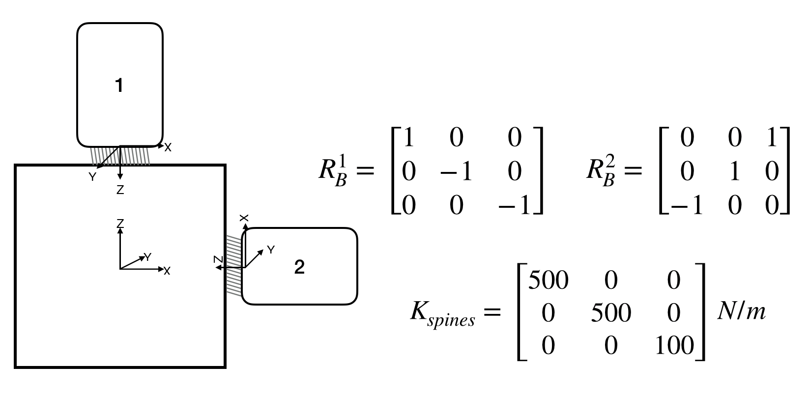

We assume moments cannot be transmitted by the small collections of spines at each fingertip.

The block is displaced by d [m] in [x,y,z] in body frame.

The feasible force space is given by the following non-convex shape:

It is symmetric about the x-z axis and its vertices (and other relevant points) are given by:

[x,y,z] [Newtons]

[0,0,0];[0,-1,0]; [0,1,0]; [-1,1,2]; [-1,-1,2];[-1,0,2];[3,-1,2]; [3,1,2]; [3,-1,-0.75]; [3,1,-0.75]; [3,0,-0.25]; [3,0,2];

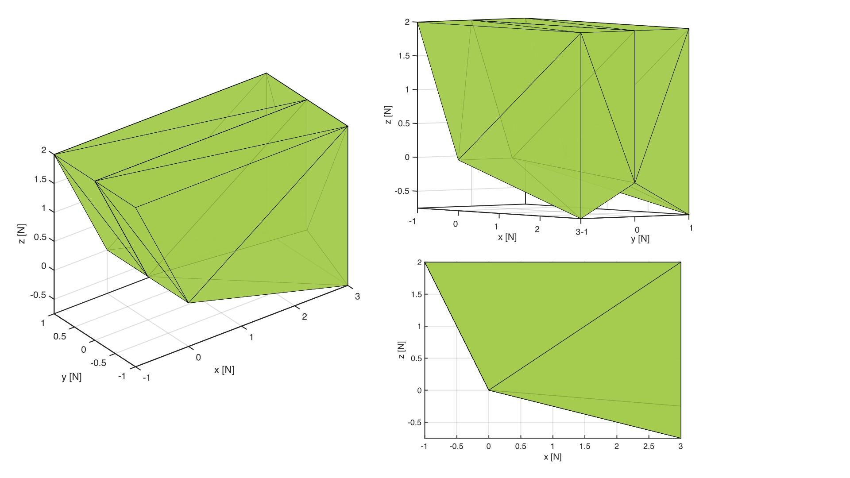

1.1. For d = [.002 .001 .002] m:

1. What are the forces at each set of microspines?
2. Can they be sustained by each set of microspines?

Tip: To make sure you are getting the forces right, try some simple displacements like d = [0.1,0,0] etc. to make sure the results make sense.

1.2. For d = [-.003 .001 -.003] m

1. What are the forces at each set of microspines?
2. Can they be sustained by each set of microspines?

1.3. What is the largest body displacement d, with y=.0015m and x,z negative, before both sets of spines can no longer provide the necessary force?

1.4. What is the largest y (x,z=0) displacement before the spines can no longer provide the required force?

Tip: MATLAB has useful functions like alphaShapes and inShape to help you with this. Similar functions exist for Python. We’ve uploaded examples for each in Canvas/Files/… Note that they work with convex shapes, so you’ll need to do your own little convex decomposition.

### Q2.

Adhesives are sensitive to uneven loads. One way to increase their performance for large areas is to employ load-sharing, so that every adhesive unit experiences the same stress. With Jiang’s load sharing, all two-tile units in an array of tiles have the same normal and tangential force. This characteristic simplifies the computation of the overall limit surface for an entire gripper -- we don’t need to build a stiffness matrix or otherwise deal with static indeterminacy.

As an example, consider the array of four two-tile gripping units below. The gripper shares an equal load among units using a pulley and tendon differential (as in Jiang et al.), and it is also able to apply moments with outriggers. However, for simplicity, we will omit outriggers in this case. The limit surfaces for each two-tile unit are equivalent. When the limit surface of the unit gripper is given, we want to:

1) compute the limit surface of the gripper in the wrench space given the limit surface for a single tile

2) find the maximum external wrench magnitude for a given direction.

Here is a simplified example of the simplified space gripper from Jiang. Et al. The gripper consists of a simple arrangement of 4 flat two-tile gripping units:

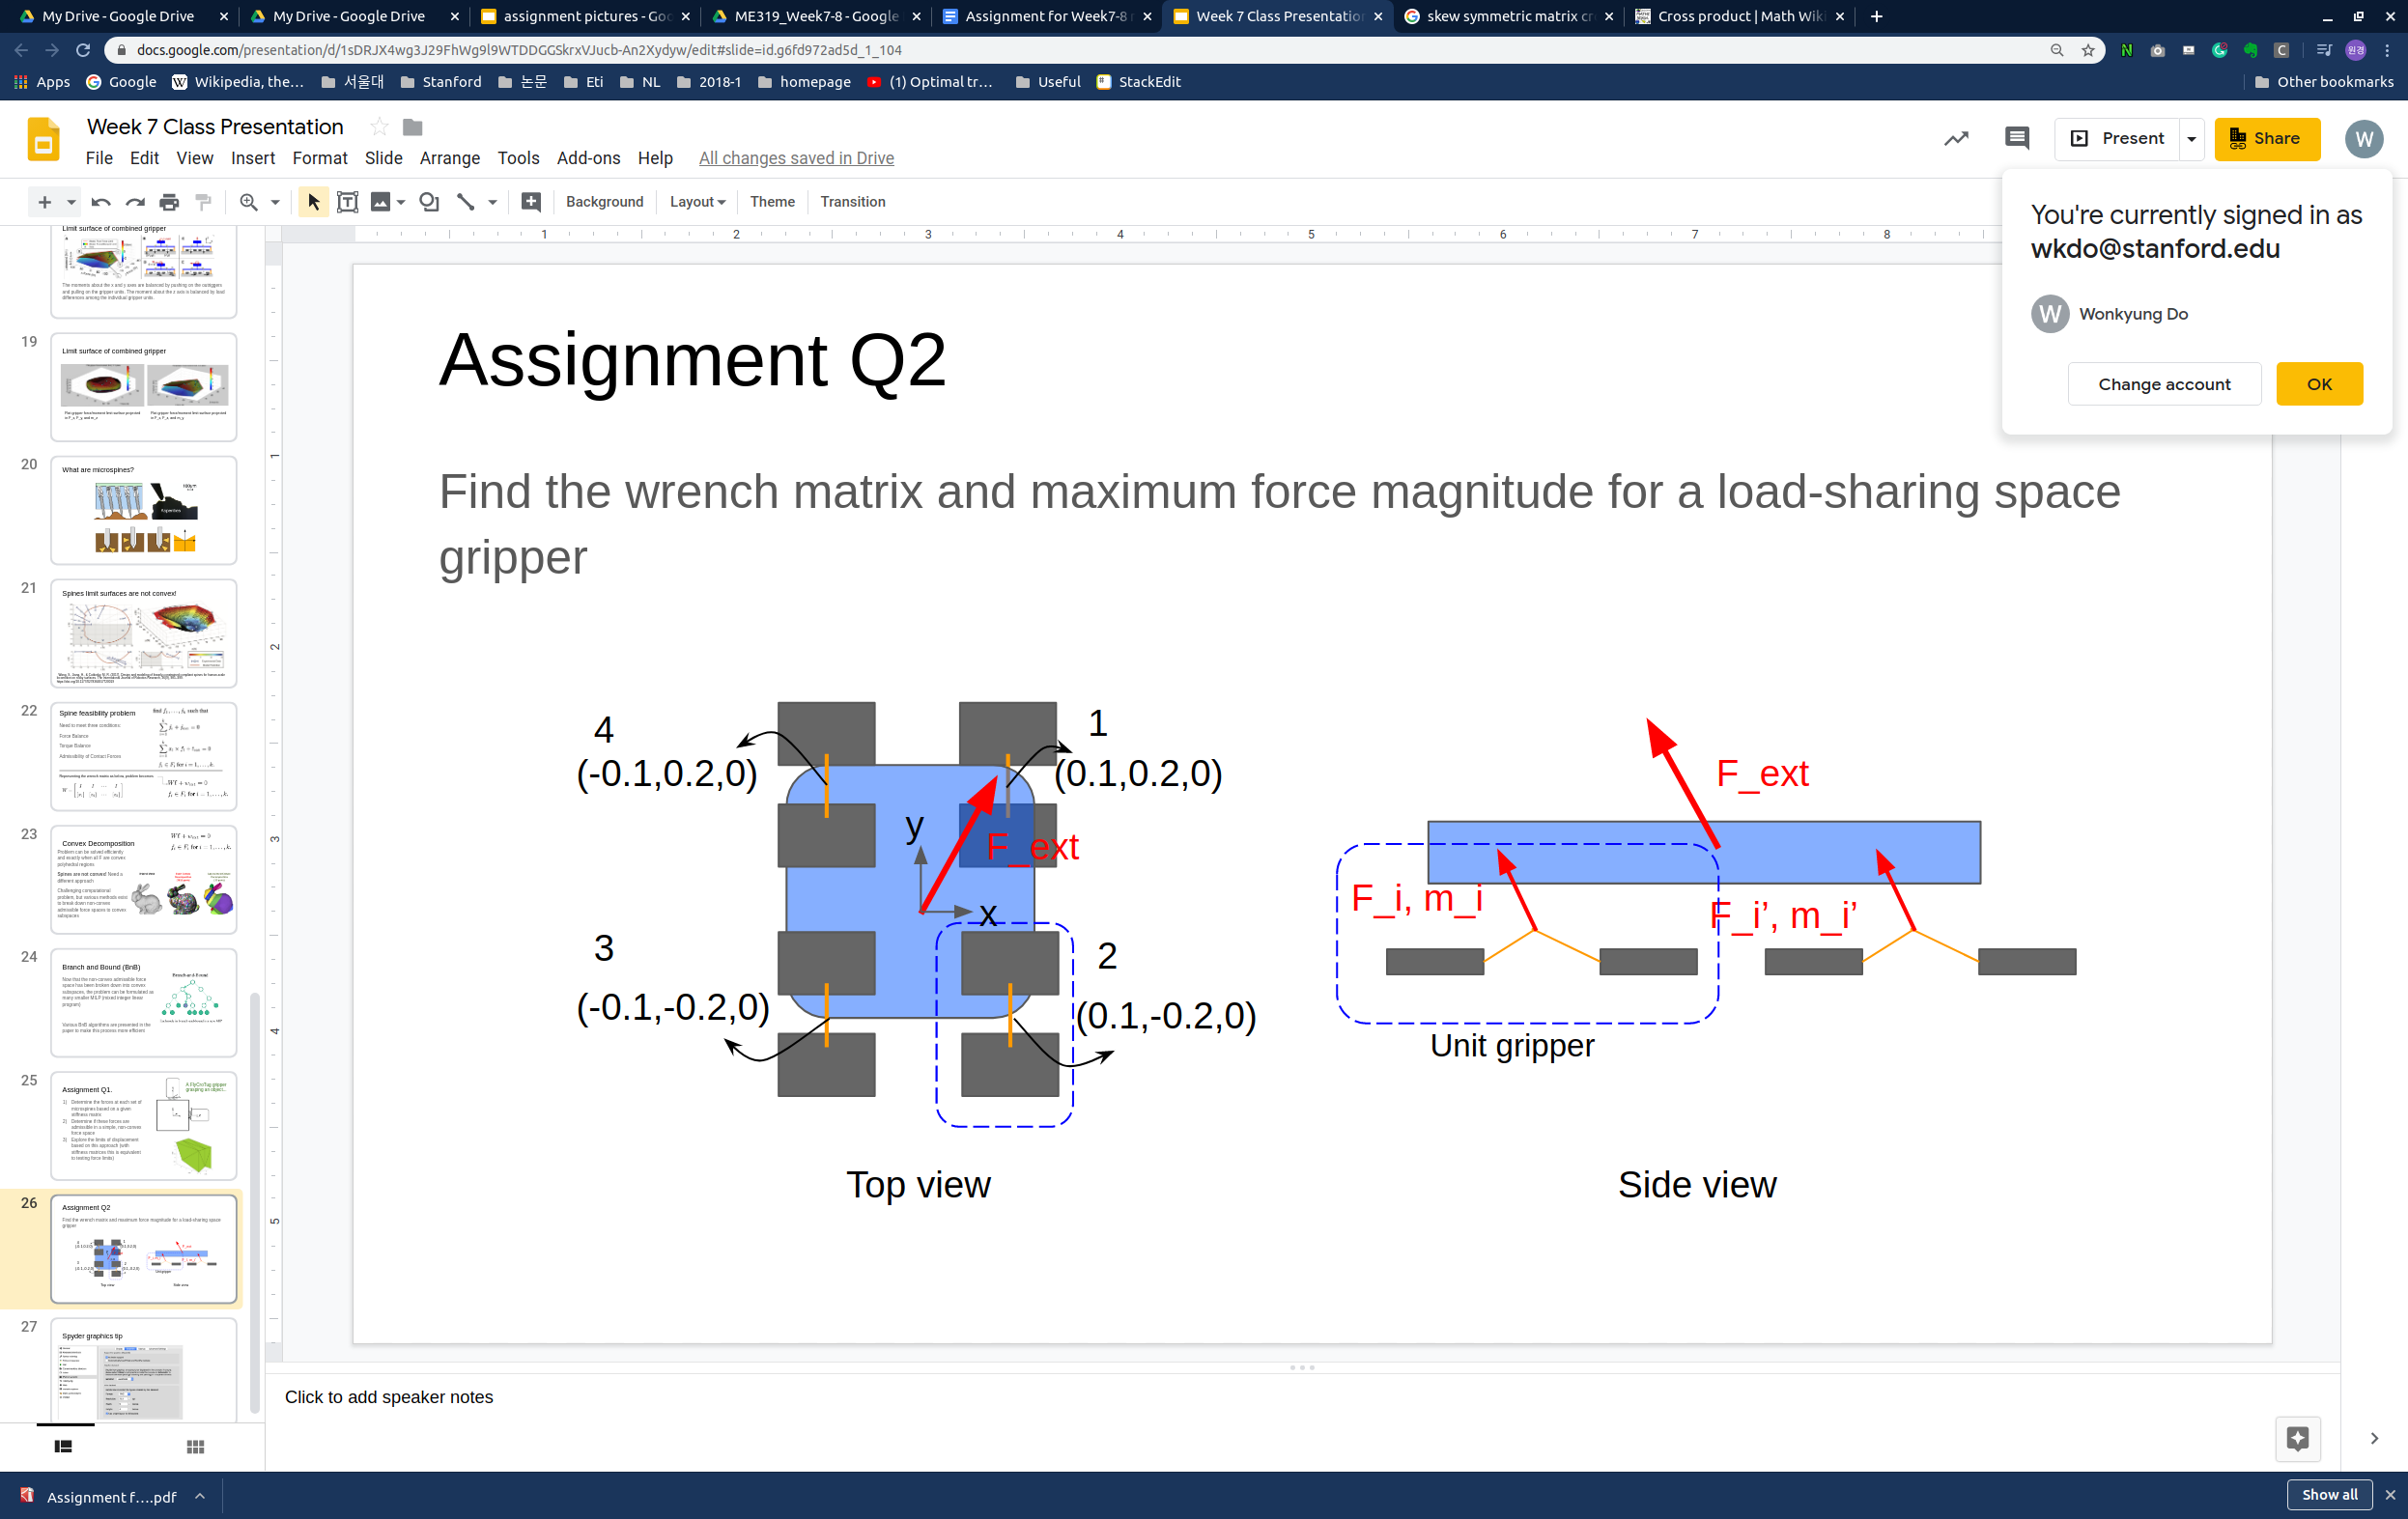

The below graph shows the limit surface of a two-tile gripping unit. 

2.1 An external force Fext = (Fx, Fy, Fz) has been applied to the space gripper. Compute the corresponding wrench of each unit gripper 1, 2, 3, and 4 in the global frame. You can assume the local and global frames are aligned.

2.2. Compute the numerical Wrench matrix for this system that maps between the two-tile unit gripper forces (fx,fy,fz) and the overall resultant external wrench [Fex, Fey, Fez, Mez]. We don’t have outriggers, so ignore moments about the X and Y axes.

2.3. If we ignore bending moments about (X,Y) and assume there is no twisting moment about the Z-axis, we can compute a three-dimensional limit surface of the system, given the diamond-shaped limit surfaces for the two-tile units. Plot this shape (include a figure printout).

2.4 Using the overall limit surface from 2.3, what is the maximum force magnitude that the space gripper can hold if the force direction is given as (7, 7, -5) in the (x,y,z) directions?